**Adler Typewriters**

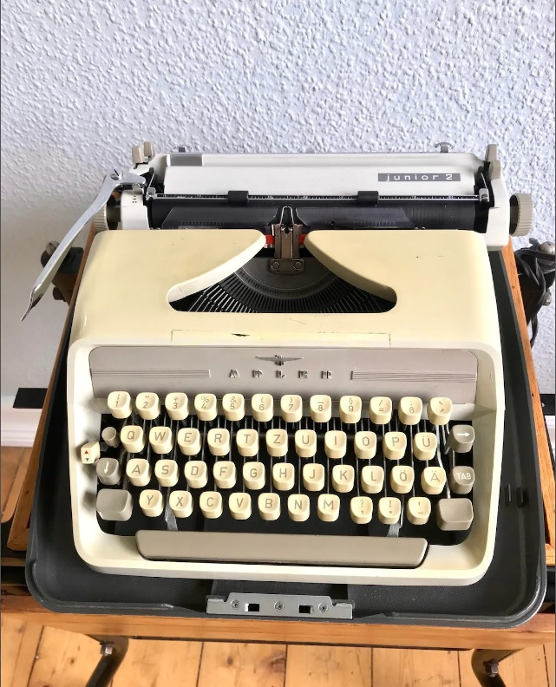

<https://www.allthingstypewriter.com/typewriter-brands/adler-typewriters/>

The age of the mechanical typewriter as an everyday essential piece of equipment has long gone, and yet the vintage typewriter still holds appeal for many. There are many makes that endure as collectibles, set pieces and useful items for those who enjoy the experience of times past, and the Adler typewriter is one of the better known names.

A brief history of Adler typewriters

The Adler typewriter owes its origins from the start of the Adler company in 1896. Initially focussing on the manufacture of motor cars, motor cycles and bicycles the company moved into typewriter production with its first model in 1898.

This first model was dubbed The Empire and it was aimed at printers and small businesses. By this time Adler had joined with Triumph-Werke to form the Triumph-Adler AH Company. The Empire was something of an immediate success and caused a stir with its unique push-rod mechanism.

The Adler 7 followed a year later and became one of the most famous of Adler’s typewriters. So well made were these machines that many were still functioning perfectly after 50 years of use.

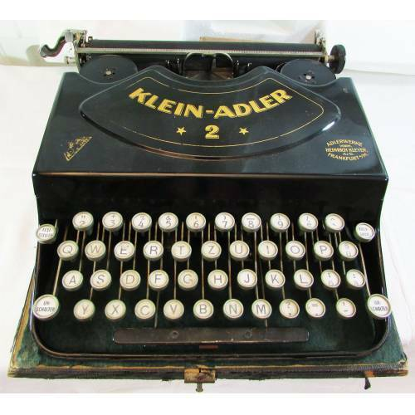

Adler’s appeal

The first are often considered the best and part of Adler’s appeal lies in their innovation right at the start of the typewriter era. Almost from the start Adler got many things right and the build quality and precision drew admiration. The name remains famous even today both among collectors and those who either stage or recall a less complicated pre-digital lifestyle. The look of an adler typewriter immediately calls to mind bygone days of such a world.

Some better known Adler models

Progressive improvements in later models such as The Universal saw Adler machines entering domestic use and famed for their precision and reliability. The Klein Adler models were lighter and more portable. The Adler 15 keyboard is not dissimilar to keyboards now in use with computers as it held 4 rows of keys.

Adler moved from giving their models numbers to names, some of the most well known being The Klein-Adler 2, The champion, Contessa, Favorit, Tippa and Gabriele.

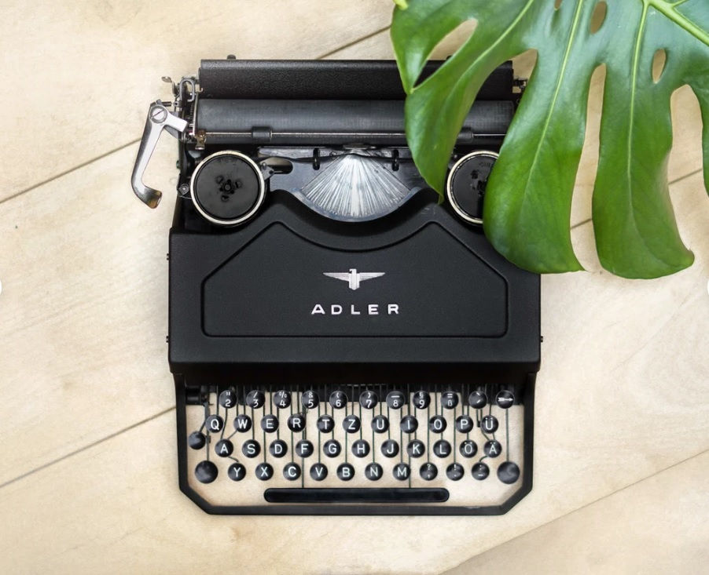

In the 1960s and 70s models came in strong colours such as orange, yellow and red. Although Adler ceased business in 1995 their machines are still in use and the name has become synonymous with the typewriter.

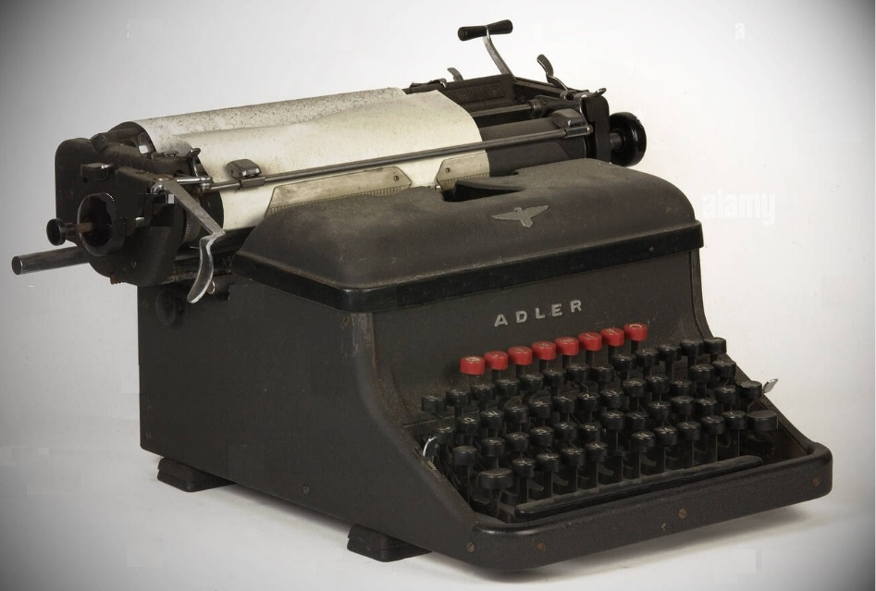

Why Adler – and other typewriters – endure

The appeal of a mechanical typewriter lies in its simplicity compared with digital devices and the tactile nature of its functioning. The sound of a typewriter feverishly clacking away as it produces text, coupled with the feel of the keys working beneath the fingers is something that cannot be replicated.

Electric machines may take some of the manual work out of the process but they still possess the same unique characteristics that will vary from machine to machine.

Each vintage typewriter, with its history and different degrees of usage and wear, is unique (that’s why police forensic departments could identify work produced on specific machines).