Outstanding German two-strokes
we shouldn't forget:
Part Four, the 1950s
By Ralf Kruger
(1/16/2012)
Editor's Note: For Parts One through Three of this series, see Motohistory News & Views 6/20/2011, 7/15/2011, 10/18/2011 respectively.
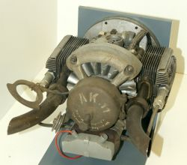
The postwar years in Germany prior to 1948 were characterized by the recreation of democratic political institutions to overcome the chaos of millions of homeless and to set requirements for reviving a collapsed German economy. Due to fuel shortages, individual transport by car or motorcycle was banned with only a few exceptions. Mobility was by train or, more likely, an old, leftover bicycle. But most simply walked to reach their workplace. With implementation of the new German currency—the Deutsche Mark—in June 1948, the German economy picked up speed, creating the opportunity for many German motorcycle brands to restart production of mostly proven and updated prewar designs.
But not all agreed with this obvious and economical approach. Norbert Riedel, who was a senior designer with Ardie prior to the Second World War, and known for designing the Riedel two-stroke boxer starter-engine for aircraft turbines built by the Victoria motorcycle factory (pictured above left), envisioned a new design for a small motorcycle under his own brand name. In 1947, he began to envision a simple but innovative motorcycle, the Imme R100.
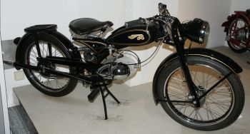
His task was to combine a modern technical layout with cost effective production, considering that any kind of raw material like steel and aluminum, or semi-finished goods like steel tubes, were still in short supply. His technical layout was bold and innovative, and simplicity was paramount. When the Imme (pictured right and below left) was presented to the public in 1948, its design turned heads, as it still does today.
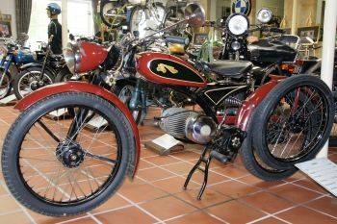
The single central tube which forms the main frame and its headstock is of the same diameter. At its lower end it meets another cross-the-frame tube, which is the pivoting point for the complete drive train. This enabled the longish exhaust pipe to double as a single-sided swing arm for the rear wheel! The complete engine/exhaust/swing arm arrangement pivots around its mounting point on the frame and moves with the rear wheel when the rear suspension is compressed. A reinforced fender, the stay arms of the luggage rack, and the swinging arm form a kind of "cantilever" triangle and supports a single shock absorber spring against the main frame tube. The front brake's normal stay-arm is deleted and replaced by a single bolt which braces in a thick tube that is the single element of the front wheel's suspension. The front and rear wheels are interchangeable.
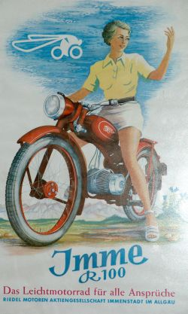
The Imme’s 98cc engine is a simple piston port two-stroke engine producing 4.5hp. Using a three-speed gearbox, the little machine can accelerate easily to a speed of 50mph. Under full load, the little engine hums like a feisty bee, hence the logo on the tank. Riedel further simplified an already simple design by eliminating a main bearing with a single-sided, overhung crankshaft. This was later altered with the Model D.
But the most impressive detail of the whole engine is its look. Germans call it "Kraft-Ei," which means “power egg," a look that Benelli and Motobi owners of later times certainly became familiar with. By autumn 1950, Riedel had sold an astonishing 10.000 copies for a very low price of 775DM, which would bring financial woes that forced Riedel to close his Immenstadt-based company at year end in 1951. A second version of his unique motorcycle, featuring a 150cc twin, was planned, but never put into production. Only three prototypes were built.
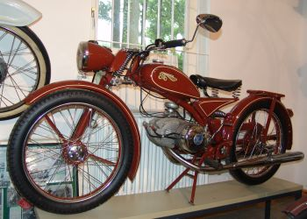
A successor company, ZMG, attempted to build a slightly modified 175cc twin (pictured below left), but only about 25 motorcycles were made before production ceased. By then, demand for such a simple, small capacity motorcycles had come to an unexpected halt. How quickly the times were changing is evidenced by the fact that 1951 Volkswagen had built its 100,000th Beetle, which would soon put manufacturers in a dire situation throughout Europe. But still, and into 1955, motorcycle sales boomed while larger and faster motorcycles were becoming more popular.
The reason I call the Imme outstanding is because of its unique approach to manufacturing a modern, ingenious, and affordable small motorcycle. It fit into a very difficult but short period of time when the purses of customers were very slim indeed.
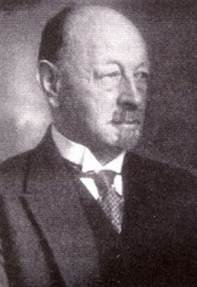
Adlerwerke, from Frankfurt, has a rich history regarding bicycles and motorcycles, dating back to 1880. It was founded by Heinrich Ludwig Kleyer (born Dec.13 1853, died May 9 1932), who was a mechanical engineer with diploma from Technical University of Darmstadt. His first commercial motorcycle, the Model 1, was built in 1901. Adlerwerke became one the more successful motorcycle firms in Germany after the turn of the century, and its success continued until 1907, until the first buzz for motorcycles in Germany was over. But this is a story in itself and will be the subject of a future article.
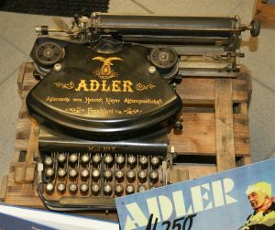
While the oldest foothold of Heinrich Kleyer (pictured right), the bicycle, was continuing to be built, the production of Adler typewriters and Adler cars became more and more important from an economic point of view. The model #7 (left) is certainly the most famous typewriter from the Heinrich Kleyer Group.
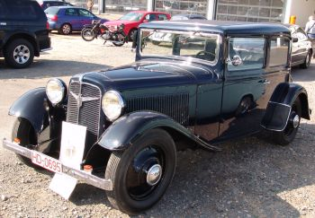
Almost simultaneously with the fabrication of motorcycles, Adler began car production. Its output stood for about 20 percent of market share in Germany before the First World War. Among the most famous Adler cars of the inter-war time were the Adler Trumpf of 1932 (below right), designed by Hans-Gustav Röhr and the Trumpf Junior, built in 1934. These were advanced cars featuring front wheel drive and independent suspension on allfour wheels. Thus, Adler had become the third largest car producer in Germany. In 1935, the Adler 2.5 liter, known as the Adler Autobahn (below left), was developed by new chief engineer Karl Jenschke. Its streamlined shape was considered revolutionary at the time.
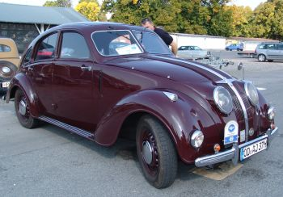
During World War II, Adler produced, among other things, machine tools and tank chassis and engines. To maintain continuing production, Adler employed forcedlaborers and concentration camp inmates after 1944. All told, about 1,600 such laborers were used, and those who survived up to 1945 were sent on a fatal death march to Buchenwald, or died at the camp itself. Today, a commemorative plaque recalls this sad history, mounted near the former main entrance of the Adler plant in Frankfurt.
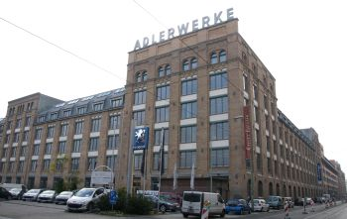
Adlerwerke in Frankfurt (pictured right) was about two-thirds destroyed from bombing during the Second World War, and afterward four branch firms in the eastern part of the country were lost. In 1948, the remaining part of the Frankfurt factory was occupied by American forces, which would not allow production to be resumed immediately. When former CEO Ernst Hagermeier was released from internment in the summer of 1948, there was hope for a new beginning, but a setback came the following year when more than a thousand machine tools from the factory floor were confiscated as reparation.
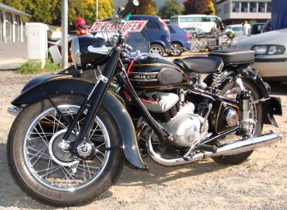
Despite these problems, it had been possible to resume typewriter and bicycle production in 1948. As it became apparent that the former machine tool and Adler car manufacturing could not be revived, the idea of reestablishing the company as a motorcycle producer caught on. A team around director Hermann Friedrich and engineer Alfred Privatstarted with a clean sheet of paper to create the new Adler M100 motorcycle. Series production began in October 1949. The new Adler was priced at 845DM, and manufacturing successfully continued until 1955.
Many German motorcyclists who had bought 100cc or 125ccmodels during the late 1940s and beginning 1950s now dreamed of owning a 200cc or 250cc. This was a demand that Adlerwerke planned to address with a completely fresh design, the M200 twin (above left) (bore 48 x stroke 54). Next came the M250 in 1952, which was nearly the same bike with a larger bore. (54 X 54).
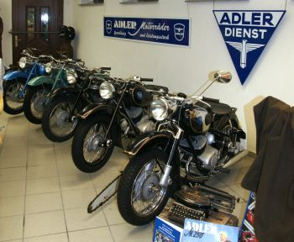
Even though the Adler twin is a piston port two-stroke, it is far from simple. The engine is loaded with progressive details which resulted in a straight forward design that is still impressive today.Its basic layout was good enough for a decade of service at least, enduring far into the sixties under the determined influence of successful tuners and racers.
To learn more about the secrets of an Adler twin, I visited the "Adlerhorst" (aerie) of Markus Voltz, a proud owner of several Adler motorcycles and who inherited his enthusiasm about Adler from his father. Markus presented a small fleet of Adler motorcycles (above right), and was so kind as to show me a dismantled M200 twin engine for its technical discussion for Motohistory.
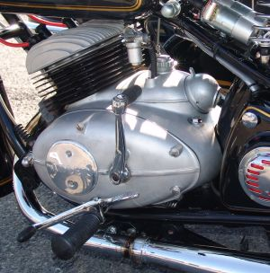
If you step back to get a better look at the Adler twin motorcycle, you will notice its comparatively small stature, sitting low on 16-inch wheels. The overall styling is typically German for the 50s. The nice teardrop tank and the implied streamline of the engine's smooth castings, which includes the gearbox and is absent of any protruding components (even the carburetor is mostly hidden) gives it an extremely tidy look (pictured left). Big fenders and a stout double loop frame add to the impression that the motorcycle might be a good touring bike, which indeed, it is. While you may appreciate these qualities, you may run the risk to missing its true character, expanded and defined by its exceptional two-stroke engine. While the modest power of 11.4 hp for the 200cc engine and 16hp for its sister model of 250cc capacity was class-leading but not exceptional, the declaration does hyde the enormously detuned status of the engine package as a whole. We’ll look at some design details to better understand why.
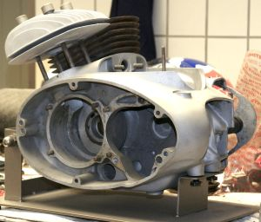
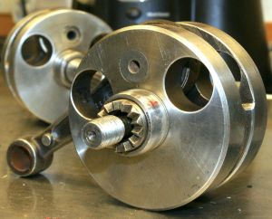
The reason two-stroke twins were so few up to the time is mainly because of sealing problems between the two halves of its single crankshaft, which is needed to gain separate pre-compression on each cylinder. Additionally, the alignment of a "built" crankshaft was not easy to mass produce. To address these concerns, engine specialist Felix Dozekal designed a rigid tunnel crankcasewith an inner longitudinal separation that houses the middle main bearing of the crank (above right). Both crankshaft halves wereinserted from either side, then connected by a single screw. To make torsional movement between the two halves impossible, and to guarantee good alignment, a self-centering Hirth gear tooth coupling was
used (pictured left). But the most interesting detail of the crankshaft is its connection with a screw. The single inner side of each crankshaft-half is bored out hollow, the left hand part includes a female thread for the bolt, and the right side the screw itself.
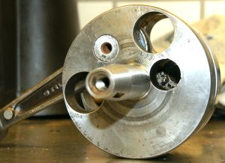
But how can you tighten this centrally located screw since the crank web covers access? Look into that additional hole in the right side's crank web (pictured right) and you will see the external teething on the bolt's head, which can be turned by a special tool, screwing both shafts in place! While the tread is a left-hand, you actually turn the special tool clockwise for tightening because the tool and screw mesh like two gears, making the driven part rotate in the opposite direction as the tool. Clever, huh?!
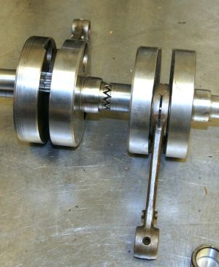
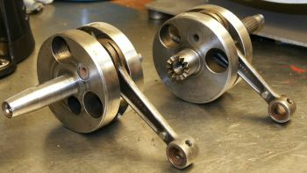
Of course, this layout has its limits and shortcomings. First, it is expensive to manufacture. And, the mechanical limits of the Hirth tooth system is the second concern. With its original M250 power output of 16hp @ 5,600rpm, later increased to 18hp @ 6,000rpm with the 1954 MB 250S and Sprinter series bike, there is no problem. The crankshaft will keep up "forever." The real save limit for the crank on the long run is about 26hp or accordingly 8,500rpm, which was the output of a 1955 water-cooled Adler RS production racer. There is even good reliability up to 28 -30hp @ 9,500rpm. These engines continue to be a favorite for extreme tuning, but I was told by former Adler racerReinhard Scholtisthattoo much output can break the teeth off the crank's coupling at its base. His own Adler racing machine delivered up to 35hp and 10,500 rpm (double the engine’s original power at twice its intended speed). His last racing season on the Adler was as late as 1967, before he changed to a used Yamaha TD1B in 1968.
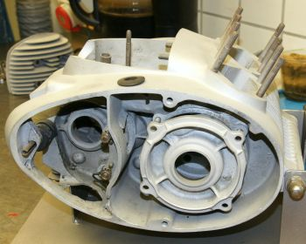
But let’s return to consideration of the 200 and 250 production engines. The complete crankshaft is supported by three main bearings, the outer ones in a separate bearing shield, which is bolted into the cases on four studs (left). All these bearings are roller type. The primary drive, located next to the left main bearing, has helical cut gears and reduces gearbox main shaft speed at a numerically high ratio of 1:3,44 against the crankshaft.
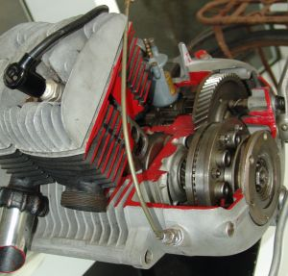
On the crankshaft's left side is the multi-plate clutch (right). This is an unusual location for this item, since it is typically found on the main shaft of the gearbox in most designs of other brands. But there is a reason for this: As the clutch turns with crankshaft speed, the effective torque per revolution is reduced by the same value as the primary gear reduction. The clutch diameter can shrink with a given friction plate number in comparison to a conventional design of a clutch on the main shaft. The added mass of 1.4kp reduces the likelihood of stalling unexpectedly because of too little flywheel effect.
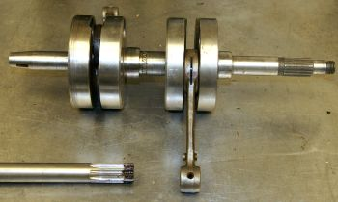
The bare crank (left) weights only 4.5kp, and the clutchdoesn't take away much of the spontaneous throttle response. On the right side of the crank, the alternator and ignition plate is mounted, which adds considerably to the overall width of the engine. The alternator is heat sensitive and tends to be the weakest design element of the engine. But to be fair, it must be said that the total closing behind the right side-cover without any ventilation provokes failure.
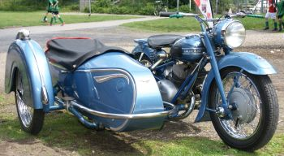
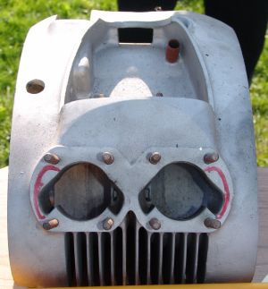
The gearbox is a four-speed unit of flawless manufacturing quality, reflecting Adler's knowledge about gear trains learned from machine tool manufacturing. Just like the crank, the gearbox's shafts are pushed into the cases from the side and fixed with another bearing shield. The gear ratios seem to be a bit weird today, with a low first, good graduation to second and third, but a big step up to the very long fourth gear. But in the 50s, this stepping made good sense because a low first gear preserved the clutch when starting from standstill with high load of a passenger or even a sidecar. Third gear of the M250 will achieve about 80kph in a hurry, so overtaking lorries or cars on a country road was easy and fast. The relatively long fourth gear was for cruising or Autobahn, where the Adler 250 could reach 120kph.
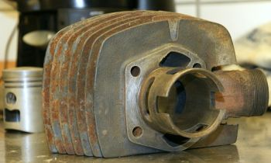
When you take a look on the crankcase from above, with removed cast iron cylinders (left), you will see the cast-in initial of the two transfer ports per cylinder. You can see the direction the gas stream is intended to flow: To the closed backside cylinder wall where it starts the typical loop of the reverse scavenging method. While this layout works with excellent results, one can't help but wonder what could be the results if the overall cross section of the transfers were enlarged to feed maybe four transfer ports in an adapted cylinder? Before you accuse me of delivering a tuningmanual for Adler twins, I can tell you I have already seen Adler M and MB250 engines equipped with Yamaha DS6/7, or even more modern Suzuki X7, cylinders. Of course, this is not easily done -- but it can be done. It is necessary to machine the upper rear part of the cases and fill missing passages by welding on additional aluminum, because the original inlet section cast into the cases, is designed for a single carburetor only.
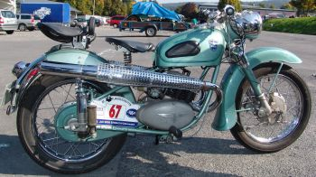
Take a look at this 1954 Adler MB250 with con-rods and pistons from a Suzuki GT380, as well as cylinders from a Suzuki X7, including its complete exhaust system. It imitates an MB250S with its up-swept mufflers. Of course, I only mention these examples of advanced wrencher's disease to underscore the enormous potential of the original Adler engine.
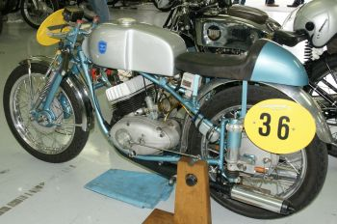
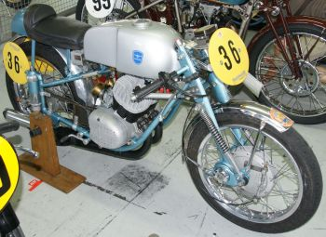
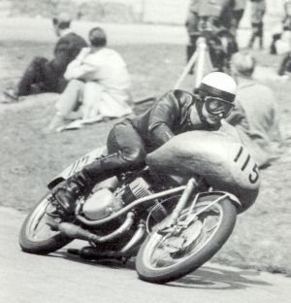
Adler fully exploited these built-in qualities of the M200 to the MB250 when the Adler RS (pictured right) arrived. Its initial development dates back to 1953 as an idea and conversion of Adler employee Helmut Hallmeier, whose work was executed without the knowledge of Adler business management. Hallmeier machined the crankcase for the adoption of two carbs, altered the exhaust port (ca23hp), and took part as a privateer in German road racing events. His good results soon came to the attention of Hermann Friedrich who gave the green light for the development of a batch of production racers. Engineer Kurt Grassmann was responsible for engine development and Willy Klee became official racing mechanic. The first M/RS type (above left), still an air-cooled 26hp version of a modified Adler M250, was sold byAdlerwerke in only 12 to 15 copies in 1953 and 1954.
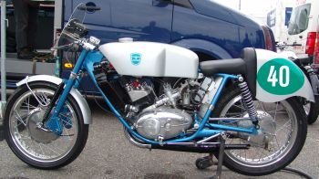
A second version of the air-cooled RS made in 1954 (pictured right) got a new frame to get rid of the outdated plunger rear suspension. It featured a different front suspension as well. Another update that year included the development of water-cooling for the 1955 season (pictured below left), a feature that could be retrofitted to the 1954 racing machines. While the maximum power was not altered, reliability of the new two-ring piston was enhanced. Sadly, a problem with fouling plugs emerged due to over-cooling of thehead. So some racers like Scholtis preferred to use the air-cooled heads or came up with designs of their own. No completeracing machines were sold in 1955 and beyond.
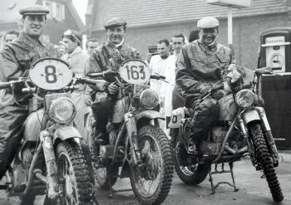
Adler's biggest success came as late as 1958, when Dieter Falk won the German 250 national championship and got fifth in the WorldChampionship as well. This achievement took place one year after Adler had closed its doors in December of 1957.
Adler's famous twin not only propelled street machines and road racers, but there was also a Six Day model which took part in the ISDT in Garmisch-Partenkirchen in 1956. Works riders Willi Bilger, GeorgSteindl, and Walter Vogel (pictured above right) took away three personal gold medals and a fourth one for success as a team. Only about 20 of these ISDT machines were built.
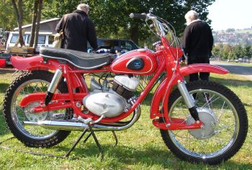
Even a motocross Adler was designed in 1956 (pictured left). Its 20hp twinwas the most powerful engine in the Adler line, lacking power only in comparison with the RS. While success was only modest in the motocross sport, its talent shone at many grass track events. Here the revvy, powerful characterof the engine was put to good advantage (pictured below).
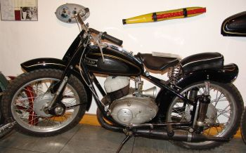
If there remains any doubt that the Adler was one of the great two-strokes of the 1950s, consider that it would soon be chosen by Suzuki and Yamaha as a model for their Colleda and YDS designs. This, I believe, stands as proof of its importance in the history of world motorcycle development.

