The demise of Adler
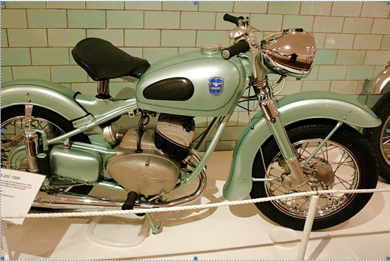
It was a pity that the marque Adler disappeared from the market in 1957. Ahead up to WWII they had nice production of cars, motorcycles and office machines. This should have been a security that the firm would handle the competition after the war. But no. First the border failed to modernize the car production of Adler and this production was ceased 1948. Adler should concentrate on motorcycles and office machines. The motorcycle production had to be merged with Triumph as the factory was placed in the English zone and the English had put their hands on the latest design of their mc. It was not possible to produce the same cycle both in England and Germany. This was the end of a great mc production since 1899. Now Adler had only the office machines left. This part was bought 1960 by the American Litton Concern. They sold it 1978 to Volkswagen and they sold what's left in 1997 to Olivetti in Italy. Lastly when the computerizing entered all was reconstructed to a Holding Concern. This used to be the end of a company where several different companies had taken all money. In this case it was only the buildings left. Those were rebuilt to factory works for different companies. This is the normal way to end a company.

