**Adlerwerke, vorm.   
Heinrich Kleyer prior to 1910**  
By Ralf Kruger  
(2/24/2012)

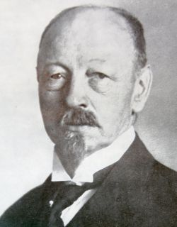**Heinrich Ludwig Kleyer (born Dec. 13, 1853 in Darmstadt, died May 9, 1932 in Frankfurt), was born into a family, whose father, Wilhelm (1822-1879), earned his living as a self-employed machinist and a manufacturer of machine tools. From his father, Heinrich inherited an affection for all things mechanical. After he successfully completed junior high school and subsequently a polytechnic institute, he finalized his academic education with an engineering diploma from Technical University of Darmstadt. A brief job with a steel-mill in Siegen followed to certify his new diploma.**

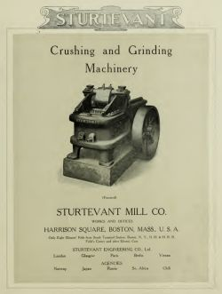When Kleyer (pictured above right) left Darmstadt for Hamburg in 1875, his first job was for the trading company, Biernatzki & Co, which imported U.S. textile machines and products made by Sturtevant Mill Company of Harrison Square, Boston, an advertisement for which is pictured left. In behalf of his employer, he left Germany in the spring of 1879 to work as a consulting engineer for Sturtevant, studying patent applications in Washington and conveying his insights to his boss.

On Friday, the fourth of July, 1879, the whole of Boston celebrated Independence Day with a big party. Part of it at 11 that morning was a race of man against machine, organized by Albert 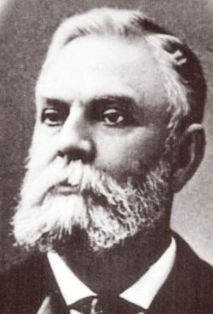Augustus Pope (1843 - 1909; pictured right), the early American fabricator and tireless promoter of the bicycle. The start was near Public Garden, and the course went along Commonwealth Avenue for a mile. Kleyer was immediately fascinated by this new kind of vehicle. To better understand its capability, he paced the course and learned he was about six times slower than the fastest bicycle. Kleyer instantly realized what the bicycle could bring for his fellow countrymen, and he decided that marketing bicycles would become his profession when he returned to Germany.

Of course, Kleyer went to see "Colonel" Pope the next day at his office at 597 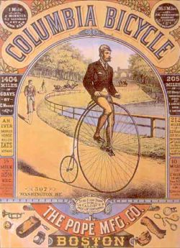Washington Street, and was offered the opportunity to visit Pope's assembly plant and retail shop, located at the time at 87 Summer Street. Upstairs, in the attic, which had been transformed a bicycle training range, Kleyer took lessons in bicycling with a so-called "penny farthing" (or "ordinary,” after the safety bicycle became popular) Columbia bicycle. The Columbia (pictured left) was Pope's first self-designed product.

Kleyer asked for one, for which he was willing to pay the retail customer price of $95 (early bicycles were very expensive), but alas, his request was decisively declined. Pope already had far too much demand for his production, so he referred Kleyer to some British manufacturers. These would also be cheaper, he explained to Kleyer.

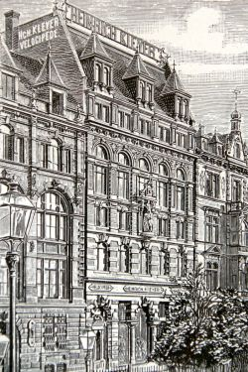When Kleyer returned from the United States, he opened his first business, Maschinen & Velocipede Handlung, located in Bethmannstrasse 8, Frankfurt, on March 1st, 1880. As a first step he began importing and sold Coventry Machinists Company "ordinary" bicycles, but he found that business was difficult. Because the bicycle was viewed with hostility by many horse owner, and seen as simply ridiculous by others.

Kleyer knew he had to improve it's image with the populace as well as government officials before bicycling could be developed into a mass market. So, he founded 1.FBC (first Frankurt bicycle club) on April, 24, 1881 to promote the idea of self-determined mobility, which until now had been limited mostly to wealthy people who could afford traveling by train or horse and coach or buggy. Kleyer's idea worked. By organizing 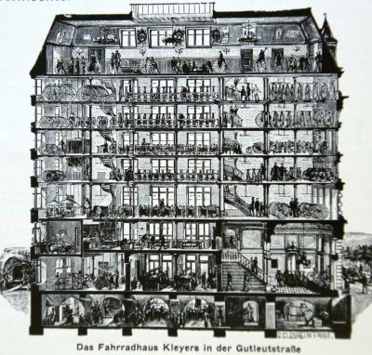bicycle races and public displays, more and more people were exposed to the potential of the bicycle, and public acceptance came quickly.

Also in 1881, Kleyer began to produce his own high-wheel bicycle with the help of Maschinenfabrik Spohr & Krämer, which supplied the frame and other components. The new bicycles were sold under the brands "Herold" (Herald, in English) "Frankfurt," and "Jugend" (adolescent).

In 1885, he moved to Gutleutstrasse 9, Frankfurt. Here he opened the “House of the Bicycle" (pictured above right) in which he could not only assemble his products, but take on frame manufacturing as well. His new 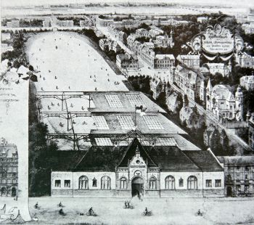facility was big enough to store 5,000Adler bicycles, his new registered trademark brand. Just as he had seen at Boston's Pope factory, the attic of his new facility was set up to be used as a riding school (above left). In addition, he purchased a big piece of land next to "Haus des Fahrrades" (House of the Bicycle) where he constructed Frankfurt's first Adler-Velodrome (pictured above right).

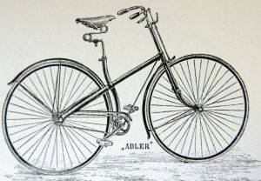While the complete manufacturing process was done in-house since early 1886, Kleyer now moved into designing and producing his first own "safety" bicycle. Adler was the first German marque to produce this new kind of bicycles, featuring two rims of the same diameter, and chain drive to the rear wheel (pictured left). Manufacturing numbers of the "ordinary," or “Penny Farthing,” slumped in a hurry.

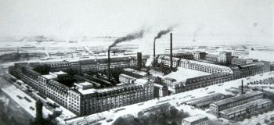The new design would bring the final breakthrough of the bicycle's public acceptation, which forced him to move his factory when Adler became overwhelmed by customer demand. In 1887 he erected his new factory in the southeast of Frankfurt at the Höchster Strasse, which was very much on the outskirts of the city at the time. Today the site has been renamed Kleyer-Strasse (above right).

With the new safety bicycle in high demand, business boomed. Just about 25 kilometers to the southwest, Opel had begun manufacturing bicycles in 1886. With Adler, Berlin's Brennabor marque, Bielefeld's Dürkopp factory, Winklhofer & Jaenicke (Wanderer) from Chemnitz, and 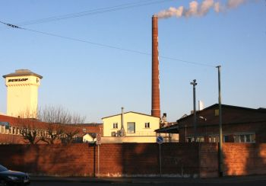Nuremberg's Victoria became the six leading makers of bicycles in Germany. NSU jointed the business in 1888, and the needs of these companies spawned a whole new component industry that included the famous FAG bearing maker and Fichtel & Sachs, which in 1895 developed the Torpedo free-wheeling hub, then redesigned it with an integrated brake in 1903.

Adler bicycles were the first marque in Germany to use inflated rubber tires, and in 1893, Kleyer participated in the establishment of Dunlop Pneumatic and Tyre Company at Hanau (above left), the first overseas branch of the original Dunlop factory in Belfast. In 1895, his "Heinrich Kleyer" company went public and its name was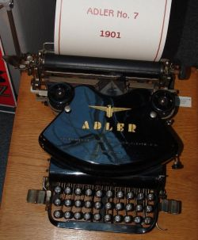 changed to "Adlerwerke, vormals Heinrich Kleyer." In 1898, he celebrated the 100.000th Adler bicycle, and at the same time established his Adler typewriter branch. Two years before, in 1896, Kleyer had acquired a license to produce the Canadian "Empire," made by Wellington P. Kidder. In 1900, the famous Adler #7 appeared. Its new push-rod design for raising pressure on the type resulted in better reproduction on paper, and became the new industry's standard. (pictured right)

But Kleyer did not stop his perpetual search for better or new ideas to broaden the company's range of products. Since 1898, he had been engaged in the development of a motor-tricycle for which he set up a manufacturing facility in a separate building within the Adlerwerke. In 1899, he produced a small lot of pre-series tricycles, which were sold to interested customers. This type of tricycle, together with the first small Adler car, were officially presented in 1900 at the Frankfurt Automobil exhibition. The engine for the tricycle was from the renown French builder DeDion Bouton. In 1901, the first prototypes of a motorcycle, the Model #1, were developed by Franz Starkloph. These also used an engine from DeDion Bouton, rated at 1 3/4hp.

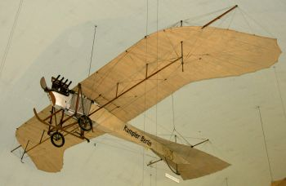After the Adler facilities for motor-vehicle production were completed, Kleyer decided it was time to develop his own engines. BecauseStarkloph had no special experience in motor design, an advertisement for an engine development expert was circulated in spring 1902. As a result, Edmund Rumpler (born in Vienna 1872; died 1940) became senior development engineer with 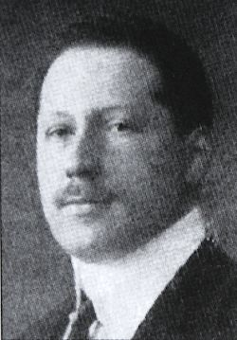Adler in the summer that year 1902. He soon proved his talent for designing modern engines, then, in 1906, founded his own aviation design office in Berlin. Today he is mostly associated with the German airplane "Taube" (dove), pictured above left.

In 1903, the Adler two horsepower Model #2 appeared (pictured below left). It was the first motorcycle designed completely by Rumpler (pictured right) and built in the Adlerwerke. It's engine, however, was still very similar to the DeDion type. It featured the same technical IOE layout with automatic inlet and standing exhaust valve arrangement. Oil-feed was still by hand-pump and carried in one chamber of a divided fuel tank. Ignition was by battery and coil, which was housed in a third compartment of the tank. For an extra charge you could purchase a Bosch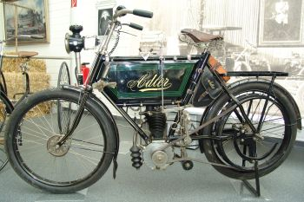 magneto as well as a carbide lamp. Ignition timing and carburetor choke were operated by riding sticks, mounted on the upper frame tube, via rods.

More development work was evident with the cycle parts. It had a coaster brake and, still more unusual, a band brake for the front wheel, which was rare and advanced device for the period. Just as uncommon was the type of silencer, which was an early type of reflecting silencer, featuring several interconnected cones and counter-cones placed over the perforated exhaust pipe (pictured below right). I believe both 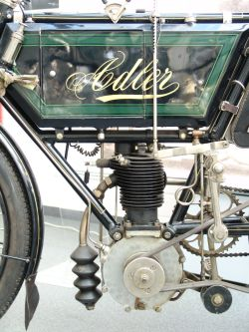novelties reflected Kleyer'sattitude toward motorcycles, which he thought safe and not too conspicuous for the wrong reason. Traffic accidents and too much noise were already becoming a common cause for complaints in a densely populated urban environment like Frankfurt.

While the frame's layout and dimension in general was still very much that of a typical bicycle diamond frame—with an added tube across the frame—it is noteworthy that the engine was located in a so-called "keystone" position. This is a configuration that all Adler motorcycles have in common. Drive to the rear wheel from the motor was by belt. There was still no clutch or gearbox. To imitate a clutch, the belt could be released and tightened with pulley operated by hand through a mechanical ratchet crank mechanism.

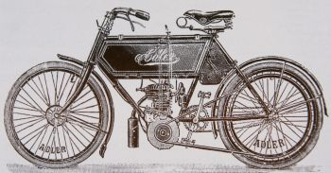Workmanship and finish of Adler motorcycles was always beyondcriticism, and I think the black and green livery with gold stripes on fenders and frame is really nice to look at.

With the year 1904 came a new generation of engine in an otherwise very slightly modified motorcycle, the 2.5hp model #3 (above left). The new motor incorporated a side-valve configuration with both valves standing in front of the cylinder. These were actuated by a gear driven cam located in the crankcases' upper part in front of 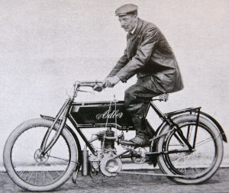the cylinder. It is among the earliest engines to offer a side-valve layout.

Still in 1904, a more powerful 3hp model was offered, incorporating a "stroked" version of the original 2.5hp engine. To place the larger engine of the 3hp single into the frame, it had to be altered by adding a distinctive kink in the tube above the engine to accommodate the taller cylinder. This new machine (above right) became the favorite bike among Adler riders who participated in sporting events, including reliability runs, relays, long distance rides, speed trials, and hill climbs.

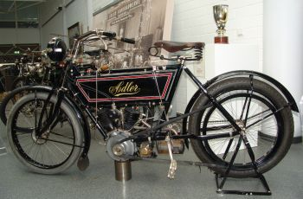Wilhelm Kellner, from Frankfurt, claimed second place in a reliability run in the Taunus Mountains near Frankfurt with his 3hp Adler. The event included ease of starting, constant running, smooth idling, braking, and slow riding tests, and Kellner earned a gold medal with 192.5 points. A long distance ride of 110km (70 miles) followed, including a speed contest up the six-mile hill at Feldberg, which was a grueling 12 percent grade on forest trail to nearly 2,000 feet of elevation.

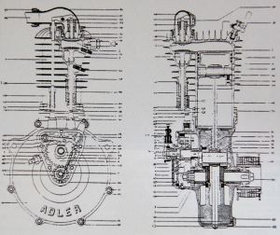1905 brought a lot of change in the Adler line. Edmund Rumpler returned to IOE valve configuration for his single cylinder engine, and designed his first V-twin (pictured above left)! Apparently, Rumpler had not been completely satisfied with his 1904 side-valve single. Maybe he recognized that what he had gained in power with his cam-actuated inlet valve he lost with lower compression in a larger side-valve engine's combustion chamber. Another concern certainly was the somewhat untidy look of the intake manifold, which wrapped around the head. So, he combined a 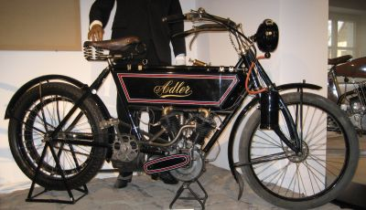traditional IOE arrangement with a new cam actuated inlet valve (pictured above right).

As with the year before, there were two single cylinder options. The Model #4 (left) could be bought with 2.5hp or 3hp engines. The frame was lengthened again for a longer wheelbase. But the most exciting development of 1905 was Adler's first 4hp V-twin. Its 576cc engine still used a single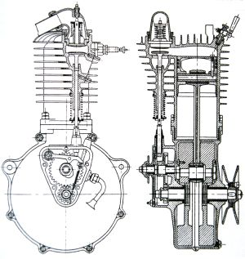 cam to provide exhaust valve actuation, while inlet remained automatic.

1906 brought new single cylinder models (right). Surprisingly, they had an automatic inlet valve like the V-twin. There was also a smaller 3hp V-twin added to the line, reflecting a trend toward cheaper and light motorcycles. Also, front and rear wheel rubber suspension was introduced.

Like many other brands in Germany at the time, in 1907 Adler ceased motorcycle production. Many people couldn't afford a motorcycle yet, and higher taxes, a bad economy, and a saturated small motorcycle market led Adler to the conclusion that car production and sales would bring more revenue.

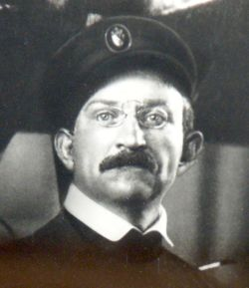August Euler (1868-1957. pictured left) was a German aircraft pioneer and rival of Hans Grade (1879-1946) (for more about Hans Grade, see Motohistory News & Views June 2011) for being the first German who would fly. He opened his first airplane factory in Darmstadt/Griesheim to manufacture licensed Voisin copies in late 1908. While the French planes were already a proven design, Euler lacked a strong engine, so he approached Kleyer in nearby Frankfurt to design a motor for him. Kleyer decided this would be a new field of commerce for Adler, so the development of zeppelin and aircraft engines began in late 1908.

In early 1909, Euler had his new Adler-built engine, whichwas a 60hp inline four-cylinder, four-stroke 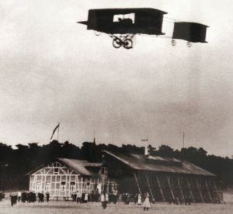motor, highly modified from Adler's car engine.

Euler became airborne on August 20, 1909 at Frankfurt's International Aviation Display, where he achieved a short 600 meter flight (pictured right), but Grade won the "Lanz Preis der Lüfte" (Award of the Skies) on October 30 that year. On February 1, 1910 Euler got his pilot's license #1, the same day that Hans Grade got license #2.

By the way, it is interesting to note that the Wright Brothers and Glenn Curtiss were keen bicyclists in America, as were Grade, Euler, and Kleyer in Germany. All five share a connection with airplanes, and all but the Wright Brothers and Euler became pioneer motorcycle builders. But this, I believe, is another story.