Adler Sewing Machine History

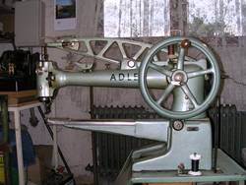

The history of this company is intermingled with the final company it merged with in 1990. hat merger brought the Koch Adler and the Durkoppwerke together. Both companies started making sewing machines in the mid 19th century but they also made cars, motorcycles, and ball bearings.

## Adler Sewing Machine Company

As stated in the history of this company there really has never been an Adler sewing machine company. It was a brand name only for the founder Mr. Koch and the name Adler was only added many years later after the brand became fairly popular.

While the Koch name doesn't live on, Adler still remains in existence as Pfaff has now joined the Durkopp Adler AG and became the DAP America company. The brand name was of more value than the founder’s name so that may be the reason why the Koch name was dropped from the title of the company.